

Planning & Regulatory Services

#### Private Sector Housing Policy

### 2016 – 2019

Building a world class city for everyone.

**CONTENTS**

|  |  |
| --- | --- |
| Policy |  |
| Forward | 4 |
| Aims and Objectives | 5 |
| Chapter 1 Strategic Context | 6 |
| Chapter 2 Review of the Private Rented Sector | 18 |
| Chapter 3 Priority 1 – Additional HMO Licensing | 22 |
| Chapter 4 Priority 2 – Regulation of Dwellings Occupied by Families or Single Occupants | 28 |
| Chapter 5 Priority 3 – Unlawful Dwellings | 35 |
| Chapter 6 Priority 4 – Housing Assistance | 37 |
| Chapter 7 Private Rented Sector Enforcement | 42 |
|  |  |
| **Appendices & Tables** |  |
| Appendix 1 – Private Sector Policy Action Plan 2016 - 2019 | 45 - 48 |
| Appendix 2 – Glossary of Abbreviations | 49 |
| Table 1 – England dwelling stock broken down by tenure, 2000 to 2012 | 9 |
| Table 2 – Performance Targets | 13 |
| Table 3 – Oxford Rental Values between 2011- 2015 | 16 |
| Table 4 – Population Distribution by Age in Oxford | 17 |
| Table 5 – Population growth in Oxford by Ward | 17 |
| Table 6 – Team budgets 2015/16 | 18 |
| Table 7 – Service request statistics | 24 |
| Table 8 – HMO Licensing targets | 26 |
| Table 9 –Modelled data on condition of stock in Oxford | 28 |
| Table 10 – Summary of enforcement notices for single occupied dwellings | 28 |
| Table 11 – Percentage of dwellings in the PRS by ward in Oxford | 30 |
| Table 12 – Growth in elderly population in Oxfordshire | 37 |
|  |  |
| **Charts, Figures & Maps** |  |
| Figure 1 – House Building in England 1950 – 2010 | 7 |
| Figure 2 – Mid-year Population Estimates & Annual Change for the UK mid-1964 Onwards | 7 |
| Figure 3 – Annual Population Change | 8 |
| Figure 4 – Tenure of Migrants | 8 |
| Figure 5 – Proportion of Dwellings, (United Kingdom) | 9 |
| Figure 6 – Tenure profile for 25-34 year olds | 10 |
| Figure 7 – First Time Buyers – House Price to Earnings Ratio | 10 |
| Figure 8 – Average UK Rental Prices | 11 |
| Figure 9 – Households by Tenure | 13 |
| Figure 10 – Growth of PRS in Oxford | 14 |
| Figure 11 - Number of households by accommodation type | 14 |
| Figure 12 - Relative changes in housing stock from 2001-2011 | 15 |
| Figure 13 – Comparison of Rents in Areas with and without Licensing | 24 |
| Figure 14 –Other households (HMO’s) in 2011 | 25 |
| Figure 15 – Service requests from PRS tenants | 30 |
| Figure 16 – Numbers of unlawful developments in Oxford | 36 |
| Figure 17 – Oxford and UK population by gender and age, 2011 Census | 37 |
| Figure 18 – Yearly referrals for Essential Repair Grants & Small Repairs | 39 |
| Figure 19 – Yearly Referrals for Disabled Facilities Grants & Flexible Home Improvement Loans | 39 |

Forward by the Leader of the Council

Introduction

At a time when there are many changes affecting the role of local authorities in respect of the private rented sector, (PRS), this document sets out the Council’s Private Sector Housing Policy for the period 2016 – 2019. It forms the basis for development of the Council’s policies relating to private housing and takes full account of our wider social housing policy.

The City Council believes that residents across all tenures should have the opportunity to live in a decent home, which is safe, warm and secure. While this policy document focuses largely on private rented premises, it also deals with other tenures, such as owner occupied dwellings where vulnerable residents are unable to maintain their properties or who require major repairs or adaptations. It is recognised that a number of homeowners, particularly among the elderly or other vulnerable groups, may not have the resources to carry out such important repairs and improvements.

It is well documented that sub-standard homes have a generally negative impact on the health of the people who live in them. There are clear links between damp, cold homes and the incidence of illnesses, such as asthma, respiratory disease, heart attacks and strokes. A home may also contain significant hazards which increase the risk of harm from falls, fire, scalds, electric shock, asbestos etc.

Studies have also shown that that the impact of poor housing is not confined to physical effects. Homes that are vulnerable to burglary, poor noise insulation, overcrowding, inadequate lighting, damp, cold, etc., may cause anxiety and depression, and can have a serious effect on children’s educational attainment and physical development.

This policy sets out the present baseline conditions of Oxford’s private rented sector housing and the City Council services that have been working to improve those conditions. It then goes on to set out how over the next three years, the Council, working with other stakeholders, will address the complex issues that affect the sector. This is vital for the future of the city; as we seek to build and maintain sustainable neighbourhoods, we must tackle poor quality housing and this will in turn delive rwider benefits for the health of residents and the quality of the city environment.

Councillor Bob Price

Leader of the Council, Leader of the Labour Group, Board Member for Corporate Strategy and Economic Development

**Aims and Objectives**

**1. Delivery**

1.1 Oxford City Council already has a successful record of dealing with Private Rented Sector (PRS) issues. A number of our policy interventions have been recognised by external bodies as exemplars of good practice and it is the intention of the Council to continue the general approach that has served the city well in recent years. The Private Sector Housing Policy will act as an overarching document setting out the Council’s priorities and targets. Actively promoting the ‘One Council’ ethos, these will be delivered principally through a series of partnership working and related action plans, which in turn relate to specific teams within the Council.

1.2 Our key priorities for this Policy are to:

* Protect the health, safety and welfare of residents through education and information and where necessary, enforcing statutory housing standards
* Improve the management and condition of the PRS by implementing proactive interventions such as licensing schemes
* Provide targeted financial assistance to residents who need it to enable them to live in decent, safe, warm and secure homes
* Actively seek to reduce fuel poverty through targeted assistance and intervention.
* Facilitate and enable the return to use of long term empty properties
* Provide services which assist residents with disabilities to enjoy and make the best possible use of their home.
* Provide preventative services which assist older residents to remain safe, secure, warm and comfortable in their own home

1.3 To achieve the above, the key drivers for this Policy are:

* To maximise the contribution that the private rented sector can make to the stock of good quality, safe accommodation
* Through a regime of reactive and pro-active initiatives, to minimise the risks to the health, safety and welfare to those living in the private rented sector
* To ensure through cross Council working and integrated corporate activity that the private rented sector does not have a deleterious impact on the urban environment

**Chapter 1**

**Strategic Context**

*Summary:- This section of the Policy explains the current state of the housing market and the background of national legislation and how this influences the setting of priorities for the Council in relation to the Private Rented Sector, (PRS).*

**2. National Policies**

2.1 In November 2011, the government published a Policy document “Laying the Foundations: A Housing Strategy for England”. The Strategy was a response to the challenges facing the sector that have emerged in recent years and which have even greater relevance today:

* buyers can’t buy – with the average age of an unassisted first time buyer continuing to rise and families struggling to ‘trade up’
* lenders are not lending enough – with high deposit requirements excluding young people and families from home ownership
* builders are not building – without consumers ready to buy and without enough land for development or access to finance
* investors are not investing – without the right framework or incentives in place
* more affordable housing is needed – to deliver new homes and support the social mobility and aspirations of tenants and communities
* tenants are struggling to pay high rents – as pressures increase in the private rented sector.

2.2 Although the main focus of the document was on the housing market as a whole, it included two chapters on proposals dealing with the growth and quality of the PRS and with empty properties. The government signalled that they wanted local authorities to make full use of their powers to tackle dangerous and poorly maintained homes.

2.3 There have not been any significant proposals for new primary legislation since the introduction of the Housing Act 2004, which implemented the Housing Health and Safety Rating System (HHSRS), mandatory licensing, additional licensing and selective licensing. Successive governments have introduced a number of regulations and have made other noteworthy consequential changes to existing legislation; however there have been no further significant changes to the regulatory framework governing the PRS.

2.4 There is at present a desire from the government to strengthen powers given to local authorities around the PRS using the current framework and a series of amendments have been introduced and further new regulations are planned. This is primarily in response to concerns about tenants being exploited by rogue landlords who provide substandard, overcrowded and/or illegally constructed accommodation, and Houses in Multiple Occupation (HMOs) that are occupied by illegal immigrants. There have also been steps taken to improve controls over letting agents and to prevent retaliatory evictions, both of which have been issues raised by many tenants who are dependent upon the PRS. It seems very likely that the PRS will be the only housing tenure that is available to many people in the future, leading the government to implement measures which will provide local authorities with the necessary controls over the worst practices found in that sector.

2.5 One reason for increased pressure on the existing stock is that the demand for housing in many areas is significantly outstripping the supply. The number of housing completions between 1950 to 2010 shows that house building by local authorities declined dramatically in the 1980’s and housing associations have not been able to make up the difference. Recently the number of new build completions suffered badly because of the recession at a time where the population was growing rapidly.

_______________________________________________________________________

Figure 1 – House Building in England 1950 – 2010

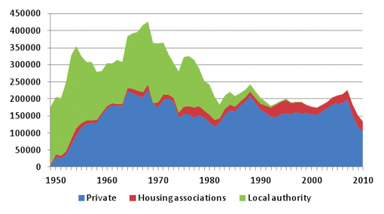

2.6 With a growing population, the number of households in England is also forecast to keep rising in the years ahead. Currently, the number of households in England is projected to grow to 27.5 million in 2033, an increase of 5.8 million (27 per cent) over 2008, or 232,000 households per year.

_______________________________________________________________________

Figure 2 – Mid-year population estimates and annual change for the UK mid-1964 onwards

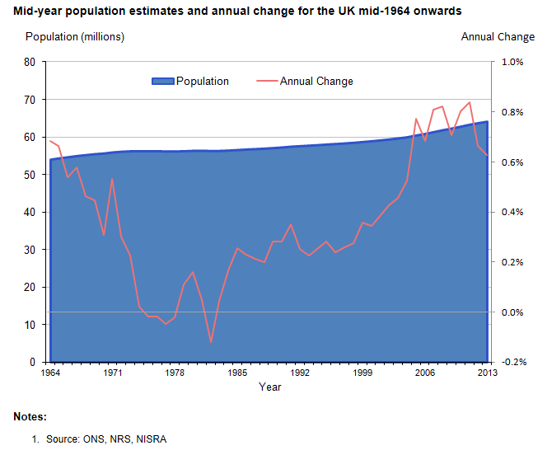

2.7 International migration contributes around 40 per cent towards this projected increase in households and the impact of migration on population growth can be seen below:

Figure 3 – Annual Population Change

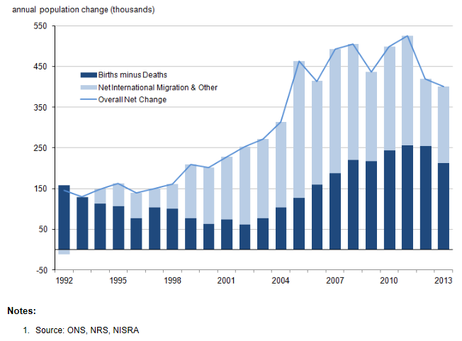

2.8 This is of particularly significance as research indicates that around 75% of recent migrants to the UK are housed in the PRS.

_______________________________________________________________________

Figure 4 – Tenure of Migrants

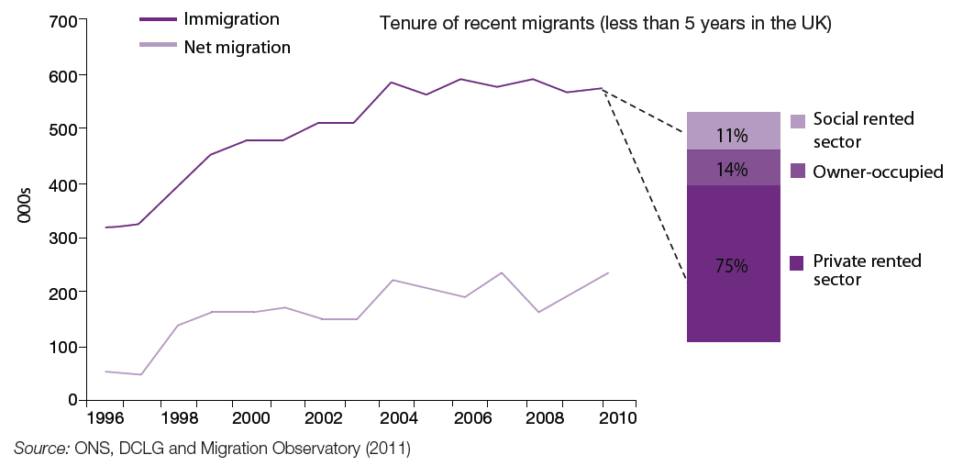

2.9 The makeup of England’s housing stock changed dramatically between financial year 2000/01 and financial year 2011/12, as can be seen from the DCLG figures in Table 1 below. The overall number of dwellings has seen growth of 9% over this period, rising from 21.2 million in financial year 2000/01 to 23.1 million in financial year 2011/12. But it is the rise of the PRS that is most striking. The PRS became the second largest tenure after owner occupation in 2010/11 and at 4.29 million units, this is the highest recorded level of private rented units since 1961.

______________________________________________________________________

|  |  |  |  |  |  |  |
| --- | --- | --- | --- | --- | --- | --- |
| Table 1 – England dwelling stock broken down by tenure, 2000 to 2012 | | | | | |  |
|  |  |  |  |  |  |  |
| Financial Year | Local Authority | Private Registered Providers | Owner Occupied | Privately Rented | Other Public Sector | Total |
| 2000-01 | 2,812,000 | 1,424,000 | 14,735,000 | 2,133,000 | 103,000 | 21,207,000 |
| 2001-02 | 2,706,000 | 1,492,000 | 14,846,000 | 2,197,000 | 112,000 | 21,354,000 |
| 2002-03 | 2,457,000 | 1,651,000 | 14,752,000 | 2,549,000 | 104,000 | 21,513,000 |
| 2003-04 | 2,335,000 | 1,702,000 | 14,986,000 | 2,578,000 | 83,000 | 21,684,000 |
| 2004-05 | 2,166,000 | 1,802,000 | 15,100,000 | 2,720,000 | 82,000 | 21,870,000 |
| 2005-06 | 2,087,000 | 1,865,000 | 15,052,000 | 2,987,000 | 82,000 | 22,073,000 |
| 2006-07 | 1,987,000 | 1,951,000 | 15,093,000 | 3,182,000 | 75,000 | 22,288,000 |
| 2007-08 | 1,870,000 | 2,056,000 | 15,067,000 | 3,443,000 | 74,000 | 22,510,000 |
| 2008-09 | 1,820,000 | 2,128,000 | 14,968,000 | 3,705,000 | 74,000 | 22,694,000 |
| 2009-10 | 1,786,000 | 2,180,000 | 14,895,000 | 3,912,000 | 66,000 | 22,839,000 |
| 2010-11 | 1,726,000 | 2,255,000 | 14,827,000 | 4,105,000 | 63,000 | 22,976,000 |
| 2011-12 | 1,689,000 | 2,304,000 | 14,757,000 | 4,286,000 | 75,000 | 23,111,000 |

Source: DCLG

2.10 The rise in the PRS can be seen clearly in the figure below:

_______________________________________________________________________

Figure 5 – Proportion of Dwellings, (United Kingdom)

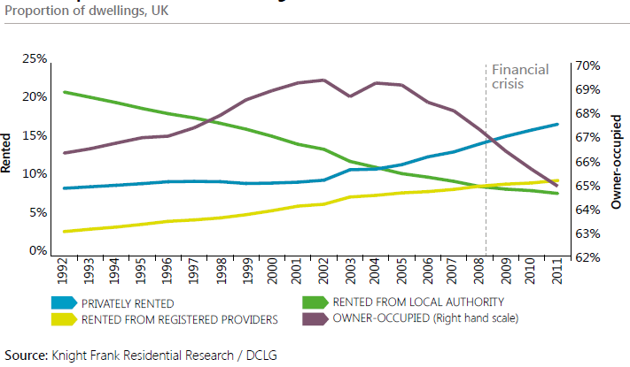

2.11 The latest English Housing Survey 2013/14 (EHS) reported in February 2015 that the PRS has now grown to 19%, up from 18% in 2012-13 and 11% in 2003 and that nearly half of 25 to 34 year-olds rent their home. (see figure 6 below).

Figure 6 – Tenure profile for 25-34 year olds

2.12 Further analysis shows that 59% of 25 to 34 year-olds owned their own home just over 10 years ago, but by 2014 this number had fallen substantially to only 36%. Rising house prices have seen many young people priced out of buying a home, while the percentage of young people renting their homes from a private landlord has more than doubled in a decade and now stands at 48%.

2.13 Affordability is another key factor that has impacted upon the housing market and the figures for house price to earnings from 1987 to 2015 show how affordability, particularly in the London (and therefore the south east) has declined.

_______________________________________________________________________

Figure 7 – First Time Buyers – House Price to Earnings Ratio

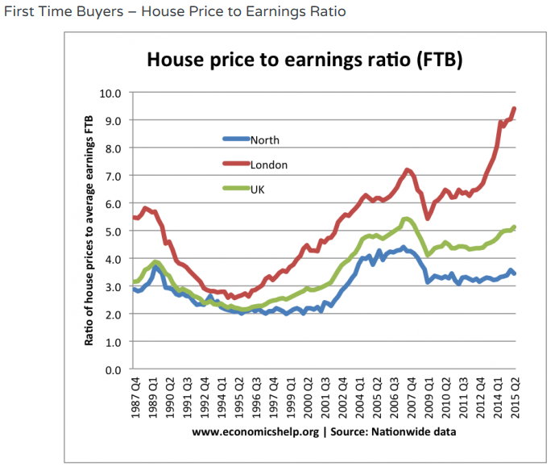

2.14 A total of 2.9 million people aged 20-34 are currently living with parents and for many in this age group home ownership is no longer a tenure of choice or aspiration resulting in the PRS being the only viable housing option.

**Impact of Buy to Let**

2.15 A key element in the development of the PRS in recent years has been the growth of the buy-to-let market. Introduced in 1996, buy to let mortgages have helped transform the PRS. Within five years, ARLA recorded a 49% increase in new landlords and in that 18 year period buy to let has offered housing to a wide range of new tenants who might, in earlier periods, have been drawn into owner occupation. A 2014 report by the Local Government Association, (LGA) estimated the number of buy to let landlords at 565,000 or 1 in 5 of all landlords. Figures published before the Government’s Autumn 2015 statement on future public expenditure, suggested that by 2032, more than one in three properties will be owned by private landlords.

2.16 Government tax changes to the buy to let market announced in November 2015, are to be phased in from 2017 and fully implemented by 2020. These changes largely affect the higher tax rate brackets, but the consequences are likely to cascade down to affect all buy to let landlords. When these changes are implemented, there may be a small reduction in the number of available PRS properties as existing landlords sell and fewer seek buy to let mortgages.

**Impact of house prices on the PRS**

2.17 Nationally, house prices are very expensive and in the UK, house price to salary ratio is amongst the highest in the developed world. In parts of the country, access to home ownership is restricted due to high prices and pressure on the PRS is driving up rents making them unaffordable for those on lower incomes and increasing spending on Housing Benefit. Rental costs have also increased considerably. The average UK rent for tenancies in October 2015 was £997pcm, 9.7% higher than the same period last year £909pcm). Figure 8 below highlights how rents have increased from 2012:

_______________________________________________________________________

Figure 8 – Average UK Rental Prices

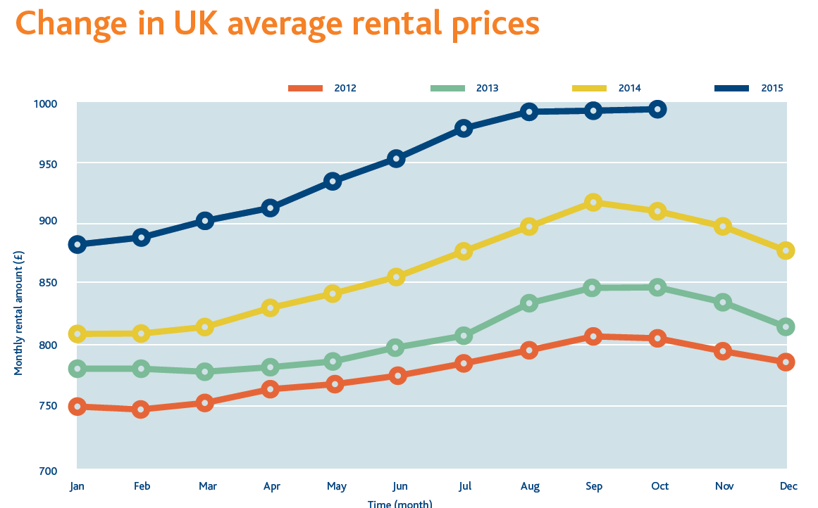

**3. Oxford - The Local Context**

**Location, Population and Characteristics**

3.1 Oxford is located in the South East region of England, 51 miles (82 km) north-west of London and is the county town of Oxfordshire. Oxford’s population grew by 12% over the decade 2003–2013, making it the eighth fastest growing English city with 158,000 residents and is projected to reach 165,000 by 2021. It is the 52nd largest city in the United Kingdom. One of the fastest growing and most ethnically diverse cities, Oxford has a broad economic base. Its industries include motor manufacturing, education, publishing and a large number of information technology and science-based businesses. The City is known worldwide as the home of the University of Oxford, the oldest university in the English-speaking world and as the "City of Dreaming Spires", a term coined by poet Matthew Arnold. It is also the home of Oxford Brookes University, one of the country’s best ‘new’ universities, with a strong orientation towards professional and technical education.

**Oxford Corporate Plan 2016 – 2020**

3.2 The City Council’s corporate plan identifies five key priorities for new investment and sets out the Councils strategic direction for the four year period from 2016 - 20. The five priorities are:

* A Vibrant, Sustainable Economy
* Meeting Housing Needs
* Strong and Active Communities
* A Clean and green city
* An Efficient and Effective Council

3.3 This policy document contains elements which contribute to all of the Council’s corporate objectives, but its main focus is on ‘Meeting Housing Need’. In the Corporate Plan the Council has committed itself to six key policy objectives, and one of these is to improve standards in the PRS by the following actions:

* reducing HMO Licence Fees for accredited landlords while increasing charges for those who fail to apply for a licence; the policy objective is to ensure that all landlords sign up for the accreditation scheme and to continue to improve standards across the city
* enforcing standards in the private rented sector more proactively
* managing the impact of private rented housing on communities and neighbourhoods. Change of use from a family or single unit dwelling into an HMO now requires planning permission. There is a presumption against new HMOs in areas which already have a significant concentration
* working with Oxford Brookes University and the University of Oxford to tackle issues relating to student housing, particularly in East Oxford
* using targeted noise enforcement as part of a programme of assistance for neighbourhoods whose character is adversely affected by HMOs and entertainment venues
* using our Home Improvement Agency to improve the homes of elderly and vulnerable home owners.
* adapting private dwellings to make them suitable for those with disabilities.

3.4 These have been translated into the performance targets illustrated in table 2 below.

Table 2 – Performance Targets

|  |  |  |  |  |  |
| --- | --- | --- | --- | --- | --- |
| **Measure Code** | **Council Priority** | **Measure Name** | **2016/17** | **2017/18** | **2018/19** |
| ED01 | Meeting Housing Need | The percentage of HMO’s subject to agreed licence provisions | 70 | 75 | 80 |
| ED04 | Meeting Housing Need | Percentage satisfaction with HIA service | 94 | 95 | 95 |
| ED05 | Meeting Housing Need | Number of proactive HHSRS inspections carried out in the PRS | 250 | 260 | 270 |

**Housing Market/****Tenure Mix**

3.5 The 2011 Census estimated a figure of 55,375 dwellings across all tenures in Oxford of which 24% were owned by their occupiers outright (no mortgage), compared with 31% nationally; 23% of properties were owned by their occupiers with a mortgage, compared with 33% nationally.

_______________________________________________________________________

Figure 9 – Households by Tenure

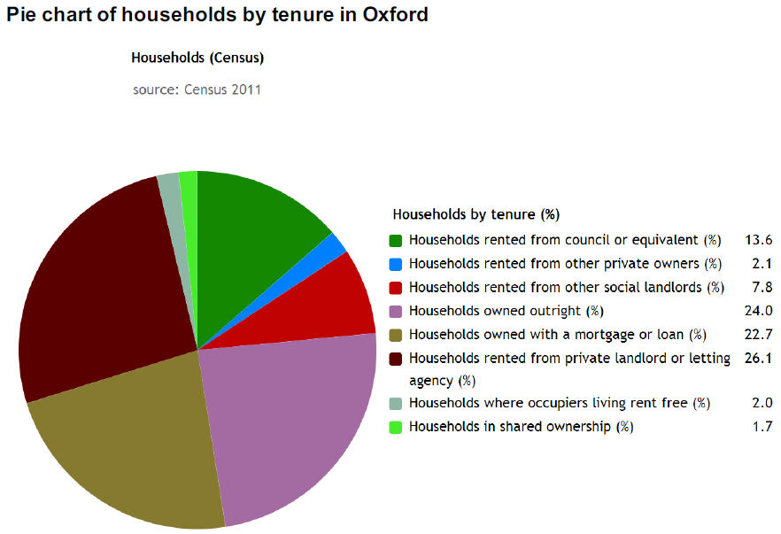

3.6 Over the last decade the PRS in Oxford has grown by almost 50%, from approximately 11,000 households in 2001 to over 16,000 in 2011. In 2011 the sector constituted 28% of the housing accommodation in Oxford compared to 17% in England.

Figure 10 – Growth of PRS in Oxford

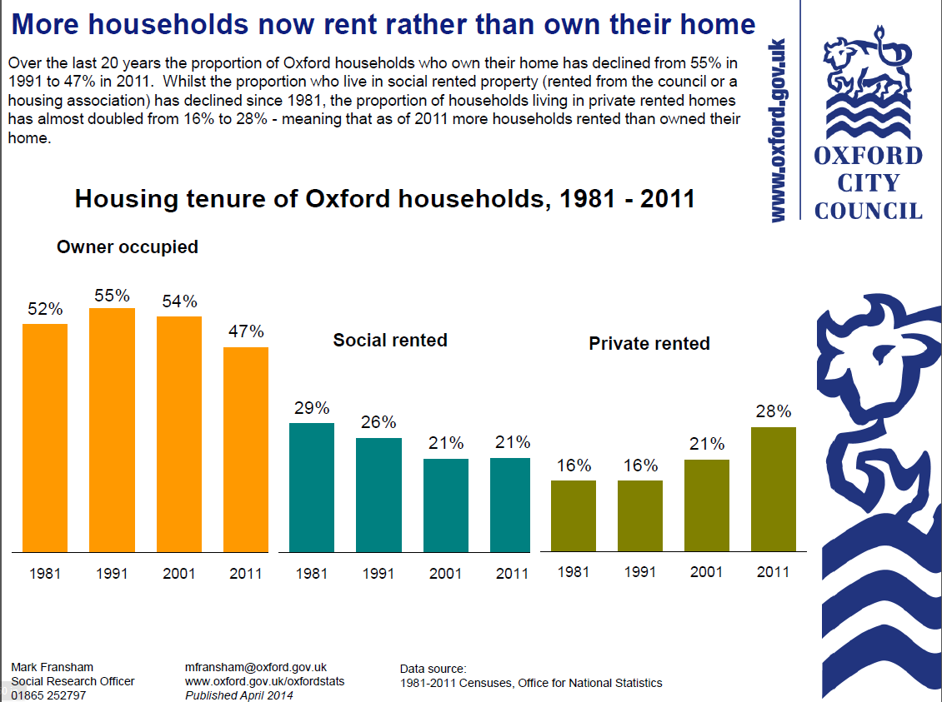

_______________________________________________________________________

3.7 The 2011 Census data provides a detailed breakdown of the different tenures in the City. The diagram below shows the situation in Oxford in comparison with the England as a whole.

_______________________________________________________________________

Figure 11 – Number of households by accommodation type

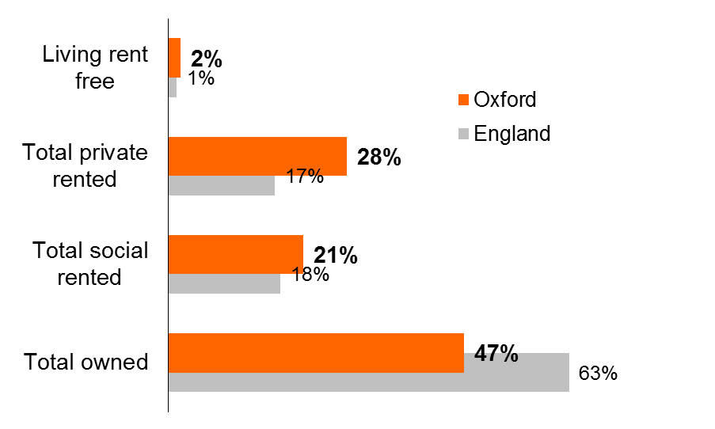

(Source 2011 Census)

_______________________________________________________________________

3.8 It is worth noting that in 2011 the total number of rented households in the city was more than the total number of owner occupied properties in the city.

3.9 There has been a marked increase in private rented accommodation in the city from 2001-2011 as shown in the figure below.

_______________________________________________________________________

Figure 12 – Relative changes in housing stock from 2001-2011

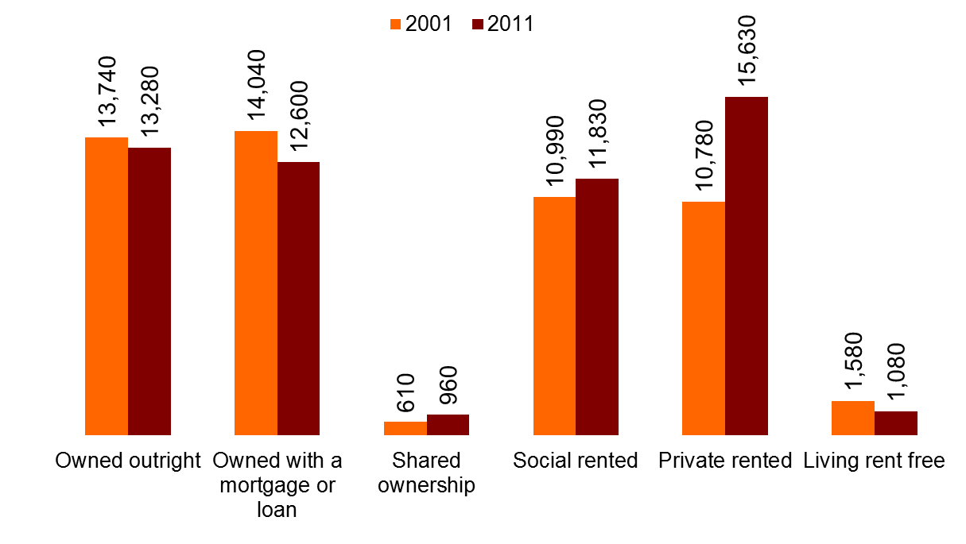

(Source 2011 Census)

_______________________________________________________________________

**Oxfordshire Strategic Housing Market Assessment, (SHMA)**

3.10 Published in April 2014, the SHMA considered the interaction between the Oxfordshire housing market and the Oxfordshire economy to examine the level of housing provision that would be required to support population growth, changes within the population (for example in terms of age structure) and committed economic growth within Oxfordshire to 2031. It also factored in the need to build affordable housing as a proportion of market housing. The SHMA does not set housing targets in itself. It provides an assessment of the future need for housing growth based on demographic and economic trends.

3.11 House prices in Oxford have traditionally risen faster than in surrounding areas. Several points that emerge from the SHMA are highly relevant to this Strategy:

* The increasing numbers of older households
* The increasing numbers of smaller households
* The significant polarisation in terms of household incomes and the extent of deprivation calculates that households will spend up to 35% of their gross income on housing costs
* The severe lack of affordable housing, at 50% above the national average and 13% above average for the South East region.
* The growth of the private rented sector in providing access to housing with 19% living in private rented housing.

**Oxford’s Housing Stock**

3.12 Overall, the housing stock in Oxford is older than the national average. 50% of the housing stock was constructed pre 1944 and the proportion of homes built pre-war is just under a third of the national average. The proportion built post 1964 is almost 60% greater with many older properties found predominantly in the owner occupied and privately rented sectors.

3.13 Semi-detached properties are the commonest property type in Oxford at 29.7% and the second most common house type is Terraced (including end-terrace) at 28.2% (Census 2011).

3.14 According to the Lloyds Banking Group ‘*Oxford continues to be the UK`s least affordable city’*, with some of the highest rents and market values in the South East of England, ‘a*t an average price of £340,864, houses in Oxford are relatively more expensive than the average earnings in the city, partly due to Oxford’s attractiveness to commuters working in London’.*

3.15 More recent research, carried out by Oxford University, concluded that the average cost of a house in Oxford had risen by almost £38,000 during the past year to stand at £426,720, making Oxford homes the least affordable to buy in the UK relative to incomes. High house prices create a situation where younger people and low income households are not able to access the owner occupation market leaving the PRS as the only option for accommodation.

3.16 A long term housing shortage where demand is high and availability is low provides an opportunity for landlords to offer substandard accommodation without any problem in finding tenants.

3.17 Rental values in Oxford have increased on average by 11% between 2011 and 2014 compared to 7% in England. According to the Valuation Office Agency the average weekly rent for a property in Oxford is now £294.25. This is also reflected in Local Housing Allowance rates in Oxford which have increased, with the average LHA rate for 2014 being £219.73 p/w.

_______________________________________________________________________

Table 3 – Oxford Rental Values between 2011- 2015

|  |  |  |  |  |  |  |  |
| --- | --- | --- | --- | --- | --- | --- | --- |
|  | | | | | | | |
| **Year** | **Room** | **Studio** | **1 Bedroom** | **2 Bedrooms** | **3 Bedrooms** | **4+** | **All  categories** |
| 2015 (May) | £492 | £708 | £886 | £1,091 | £1,346 | £2,088 | £1,232 |
| 2014 | £479 | £723 | £861 | £1,067 | £1,319 | £1,973 | £1,177 |
| 2013 | £472 | £623 | £834 | £1,025 | £1,261 | £1,924 | £1,151 |
| 2012 | £434 | £631 | £807 | £991 | £1,202 | £1,789 | £1,103 |
| 2011 | £383 | £599 | £773 | £970 | £1,163 | £1,691 | £1,064 |
| Variance % from  2011 to 2015 | 28% | 18% | 15% | 12% | 16% | 23% | 16% |

**The Oxford Population Profile**

3.18 Oxford’s population has increased by 12% in the last decade. However, unlike the national picture, Census 2011 data suggests that it is the younger population on the increase with a decline in the over 75’s. Currently 34% of the population of Oxford is aged between 20-35 years and the area has the highest proportion of students in England and Wales.

Table 4 – Population Distribution by Age in Oxford

|  |  |  |  |  |  |  |
| --- | --- | --- | --- | --- | --- | --- |
| **Age Groups** | **2001** | **2011** | **2016** | **2021** | **2026** | |
| **0-19** | 23% | 23% | 24% | 24% | 25% | |
| **20-44** | 46% | 47% | 46% | 44% | 43% | |
| **45-64** | 18% | 19% | 19% | 20% | 20% | |
| **65 +** | 13% | 11% | 11% | 12% | 13% | |
|  | | | | | | |  |  |  |  |

Table 5 - Population growth in Oxford by Ward

|  |  |  |  |  |
| --- | --- | --- | --- | --- |
| **Area** | **2011 Population Numbers** | **2011 Percentage Increase since 2001** | **2015 Percentage Increase since 2001** | **2026 Percentage Increase since 2001** |
| **OXFORD** | **135,509** | **11%** | **15%** | **19%** |
| Barton and Sandhills | 5,934 | 21% | 29% | 66% |
| Blackbird Leys | 5,843 | 2% | 5% | 19% |
| Carfax (& Holywell) | 8,931 | 12% | 19% | 25% |
| Churchill | 6,131 | 15% | 16% | 20% |
| Cowley | 5,507 | 6% | 9% | 11% |
| Cowley Marsh | 4,947 | 23% | 32% | 33% |
| Headington | 5,673 | 7% | 10% | 10% |
| Headington Hill and Northway | 4,925 | 8% | 14% | 12% |
| Hinksey Park | 5,888 | 11% | 11% | 10% |
| Iffley Fields | 5,290 | 7% | 7% | 9% |
| Jericho and Osney | 5,952 | 10% | 16% | 16% |
| Littlemore | 5,697 | 12% | 39% | 39% |
| Lye Valley | 6,208 | 9% | 13% | 14% |
| Marston | 6,166 | 5% | 9% | 8% |
| North | 5,492 | 12% | 13% | 12% |
| Northfield Brook | 6,477 | 5% | 5% | 4% |
| Quarry and Risinghurst | 6,028 | 12% | 14% | 19% |
| Rose Hill and Iffley | 6,074 | 12% | 20% | 19% |
| St. Clement's | 5,794 | 16% | 18% | 17% |
| St. Margaret's | 4,670 | 18% | 21% | 20% |
| St. Mary's | 5,085 | 10% | 9% | 9% |
| Summertown | 7,108 | 8% | 10% | 9% |
| Wolvercote | 5,689 | 6% | 21% | 28% |

Source: Census 2011

3.19 The large numbers of students and young people ensure that the demand for rented accommodation remains high.

**Chapter 2**

**4. Review of the Private Rented Sector**

*Summary:- This section of the Policy reviews the Council’s regulatory work in relation to the Private Rented Sector and details recent regulatory changes affecting the sector.*

4.1 The teams currently responsible for regulating the PRS and for administering Housing Assistance are contained within the Environmental Health Service which forms part of Planning and Regulatory Services. The teams comprise, the Private Sector Safety Team, (PSST), the HMO Enforcement Team, (HMOE) and the Home Improvement Agency, (HIA). Adopting a positive and pioneering approach to securing the highest standards possible, the core function of the teams is to ensure that minimum standards are met and maintained. The work of the teams often goes beyond this, advising and intervening to help tenants, owner occupiers and landlords with a wide range of housing issues.

4.2 The budgets for the three teams for 2015/16 were as follows:

Table 6: Team budgets 2015/16

|  |  |  |  |
| --- | --- | --- | --- |
| 2015/16 | HMO Licensing | Private Sector Safety | HIA |
| Employees | 545,859 | 313,074 | 53,095 |
| Supplies etc. | 42,596 | 4,000 | 50,550 |
| Support Services | 131,746 | 73,043 | 46,742 |
| Income | 730,000 | 35,500 | 132,500 |
| Total | -9,799 | 354,617 | 17,887 |

4.3 The private sector makes a major contribution to the supply of housing in Oxford and the service seeks to develop a positive working relationship with all landlords who share the objective of providing good quality housing. Landlord forums have been regularly held to allow an active exchange of information on housing issues and minimum standards for landlords that rent to both families and who let their properties as HMOs. Landlord Accreditation was introduced in 2009 and has recently been reviewed. It includes training and education workshops for landlords and letting agents. The focus of the service provided by the Council is on developing positive joint working to achieve the highest standards possible.

**Inspection and Enforcement**

4.4 The Council has a responsibility to deal with unsatisfactory housing and in particular has a duty to take action to deal with Category 1 hazards as defined by the Housing Act 2004. Nationally, conditions in the PRS tend to be less satisfactory than in owner occupied homes. It is for this reason that enforcement forms the core function of the Council, dealing with hazards using the HHSRS and with other associated housing problems using appropriate statutory powers.

4.5 Whilst the teams work hard to develop a professional and constructive relationship with responsible landlords, the need to ensure that all properties meet minimum standards is paramount. A firm but fair policy on enforcement in accordance with our published procedures is adopted with regular service of statutory notices in cases where informal action has proved ineffective or is inappropriate.

4.6 If there is a statutory charging mechanism the Council will seek to recover the full costs of providing its services wherever that is possible.

4.7 Charges are made for the serving of formal notices under the Housing Act 2004. If properties are rented in a condition that requires statutory intervention the City Council will endeavour to recover the costs incurred. Similarly the Council will adopt the highest penalties in Fixed Penalty Notice regimes.

**Planning and the PRS**

4.8 An Article 4 Direction removing permitted development rights was introduced which came into effect on the 24th February 2012 across the City as there was a need to manage the balance of dwellings and high concentrations of shared houses. The Article 4 Direction introduced a local control - the need for planning permission to be granted for the change of use between a family dwelling house (C3) and a small HMO (C4).

4.9 The Article 4 Direction runs alongside the additional licensing scheme for HMOs and a planning policy was introduced in order that decisions could be made and a balance of housing, in terms of family and shared housing across the city could be maintained. The controls introduced by the Article 4 Direction (and planning policy to support it) are not linked to or dependent upon the HMO Licensing regime. As a result close working between the services is required to ensure a consistent approach is maintained.

4.10 The Private Sector Housing Policy recognises the importance of maintaining a balance of housing types within Oxford and supports the role of the planning to ensure that the balance of housing is maintained across the city through an appropriate planning policy.

4.11 Of importance for the policy will be the understanding of the PRS and market drivers in planning for its growth. Investment in the PRS in Oxford is market led, often moving to locations within the city where demand is high and schemes can be viably delivered.

4.12 Included as part of the Councils long term core planning strategy is the provision of other tenures in order to maintain a balanced housing supply over the long term to promote mixed communities.

**The Energy Act 2011**

4.13 The Act introduces regulations for landlords which come into force in 2016 and 2018. Landlords are already required to provide an Energy Performance Certificate, (EPC) for their properties to new tenants and from April 2016, tenants will be able to request in writing energy efficiency improvements to their properties and landlords will not be able to refuse reasonable requests. From April 2018, properties will not be permitted to be let if their EPC energy rating score falls below the minimum threshold following an Energy Performance assessment (F and G).

4.14 The anticipated impact is a rise in demand in the service resulting from tenant’s expectations to improve energy efficiency. It is for this purpose that the Environmental Health Service is working with the Energy & Natural Resources Team to target the lowest performing properties to ensure compliance and have started carrying out proactive visits where excess cold is likely to have a detrimental impact on health. This is an on-going project which will feed into other initiatives, for example the 2015/16, ‘Better Housing Better Health’ initiative. Cold damp homes will addressed in two ways, firstly by reducing energy bills through improving the property’s energy efficiency and secondly addressing health impacts by targeting the vulnerable for this energy efficiency work.

**The Redress Schemes Order 2014**

4.15 The Order made it a legal requirement for all lettings agents and property managers in England to join a Government-approved redress scheme. Implemented on the 1 October 2014, it allows tenants and prospective tenants in the private rented sector to complain to an independent person about the service they have received. The intention of the legislation is that by making it easier for tenants to complain about bad service, this should prevent disputes from escalating. The Order is enforced by the Environmental Health Service and to date compliance has been very high as it is very easy for a letting or management agent to join a redress scheme.

**The Deregulation Act 2015**

4.16 Introduced on the 1st October 2015, the effect of Section 33 of the Act is to provide six months’ protection from eviction for a tenant occupying a dwelling under an assured short hold tenancy, where a relevant notice has been served by a local housing authority in relation to a dwelling. The purpose is to prevent retaliatory evictions in instances where a tenant has reported conditions of disrepair to the Local Authority. The Act initially only covers new tenancies, although from 1st October 2018 it will apply to all tenancies. The anticipated impact is a rise in the demand for tenancy relations advice and additional demand for intervention by the Environmental Health Service.

**The Smoke and Carbon Monoxide Alarm (England) Regulations 2015**

4.17 With effect from the 1st October 2015, these regulations have for the first time made it an offence for landlords not to provide smoke and carbon monoxide alarms within their properties in prescribed locations. The requirement is to have at least one smoke alarm installed on every storey of a rented property and a carbon monoxide alarm in any room containing a solid fuel burning appliance (e.g. a coal fire, wood burning stove). After that, the landlord must make sure the alarms are in working order at the start of each new tenancy. The penalty for non-compliance is to issue a remedial notice requiring a landlord to fit and/or test the alarms within 28 days. If the landlord fails to comply with the notice, the Council can arrange for the alarms to be fitted and/or tested with the occupiers consent. Failure to comply can also incur a civil penalty charge on the landlord of up to £5,000.

4.18 It is anticipated that powers under Part 1 of the Housing Act 2004 will continue to take precedence to ensure adequate fire safety on the basis that remedial works can be carried out with more expediency.

**Impact of the Immigration Act 2014**

4.19 Right to Rent was introduced under Part 3 of the Immigration Act 2014 as part of the government’s reforms to build a fairer and more effective immigration system. The first phase was trialled in parts of the West Midlands, and the will be applied nationally from February 1st 2016. UK Visas and Immigration are the enforcing authority. Under the new regulations, landlords will be required to check a potential tenant’s ‘Right to Rent’ and those who fail to do so may face a penalty of up to £3,000 per tenant. The regulation will mean that private landlords, including those who sub-let or take in lodgers must check the right of prospective tenants to be in the country. The government has portrayed the issue of ‘beds in sheds’ as being about illegal immigration and tackling it has become part of wider government measure to clamp down on undocumented migrants as has the proposed Housing and Planning Bill.

**Housing and Planning Bill**

4.20 On publication of the Housing and Planning Bill the Government said it would kick-start a “national crusade to get 1 million homes built by 2020” and transform “generation rent into generation buy.” However, approximately a third of the Bill relates to new powers to deal with rogue landlords, indicating that controlling the worst parts of the PRS will remain a priority for the foreseeable future.

4.21 Parts 2 and 3 will give local authorities additional powers to tackle rogue landlords in the private rented sector. They will gain the ability to apply for banning orders against private landlords. A database of rogue landlords and agents will assist authorities in England in carrying out their enforcement work. There will be a strengthening of Rent Repayment Orders to allow tenants to claw back rent when they have had to endure poor conditions. Landlords will benefit from a clear process to secure repossession of properties abandoned by tenants.

4.22 Part 5 covers a range of measures including changes to the ‘fit and proper person’ test applied to landlords who let out licensable properties and allowing arrangements to be put in place to give authorities in England access to information held by approved Tenancy Deposit Schemes with a view to assisting with their private sector enforcement work. Financial penalties will be able to be imposed on landlords by local authorities for failing to licence HMOs rather than having to resort to prosecution.

4.23 Whilst the Bill still has some way to go before it becomes law, there are some welcome powers that will help local authorities tackle the worst part of the sector.

**Technical Paper on Extending Mandatory HMO Licensing**

4.24 The government have issued a technical paper on extending HMO licensing. Whilst this will have little impact in Oxford, it indicates the government’s direction of travel and even contains an inferred criticism of those local authorities who have not used their discretionary powers to increase the regulation of the HMO market.

**Chapter 3**

**5. Priority 1 – HMO Licensing**

*Summary:- This section sets out the key issues of HMO licensing and highlights the scale of the impact of HMO’s in the City. It further details the key findings and actions that will help deliver a robust Additional Licensing scheme to ensure that it continues to secure improvements in this sector.*

**Context**

5.1 Regulating HMOs has been a priority for the Council since the mid 1980’s and a succession of initiatives have been implemented to improve conditions in the worst part of the stock in the City.

5.2 The primary driver for all of the work carried out by the Council is the protection of the health, safety and welfare of residents living in HMO`s whether it is acting in an advisory role or regulatory role through enforcement. The outcome of this work is a healthier and safer environment in which people live.

**Licensing of HMO’s**

5.3 When Mandatory Licensing of HMO’s was introduced in April 2006, Oxford City Council implemented a rigorous approach to processing the requirements of the legislation. Mandatory licensing only applies to three storey HMOs which are occupied by five or more people.

5.4 The mandatory licensing process was used to upgrade each property to a decent standard with all licences being issued ***after an inspection*** of the HMO. This has enabled the Council to have a positive impact on conditions and management of higher risk HMOs and to regulate approximately 550 properties.

5.5 Where compliance has not been achieved then enforcement has taken place giving tenants and neighbours confidence that the Council are addressing any issues relating to mandatory HMOs.

**Additional Licensing of HMO’s**

5.6 The majority of HMOs in Oxford are not three storey properties and following the introduction of mandatory licensing it became clear that the unlicensed HMO stock was generating far more problems than those HMOs that had been licensed. Despite a period of strong enforcement action it became clear that further powers were required to deal with the issues of poor management and to improve property conditions in all the HMOs in Oxford.

5.7 In 2010 the Council became the first Local Authority in England to designate the whole of its area for an Additional Licensing scheme. Phase 1 commenced on the 24th January 2011 and Phase 2 on the 30th January 2012. The scheme runs for a period of 5 years and the Council has reviewed and approved the renewal the scheme for a further 5 years to 2021.

5.8 The overall purpose of the licensing scheme is to: *‘alleviate the housing situation by setting and maintaining minimum standards across the city in the most vulnerable sector of Oxfords private rental market’*.

5.9 The scheme makes a major contribution to the Council’s corporate priority of Meeting Housing Need.

**Key Successes of the Licensing Scheme**

5.10 Since the introduction of the Additional Licensing scheme in 2011 the City Council has delivered a number of key outcomes that have contributed toward the success of additional licensing.

* The Council has issued licences for some 3,440 HMO’s and has received in total around 7,000 applications for new and renewed licences up to the end of September 2014
* Over 90% of the licences issued required additional works to be carried out to improve property conditions and this resulted in an estimated £3.2m being invested in the worst housing stock in the City.
* On average 80% of applicants had to be reminded to submit a licence application
* The Council responded to 2,754 service requests relating to issues about conditions in HMO’s
* A total of 19,746 visits have been carried out to HMO’s
* Overall 80,339 mandatory and discretionary conditions have been attached to all licences
* Around 49,000 discretionary conditions have been required on licences to deal with a lack of acceptable minimum standards and management. 12,600 related to Fire safety, 35,000 to Health and Safety, and 1,600 to amenities and facilities
* During 2013-14 approx. 34% of works to comply with licence conditions had been completed at the time of a re-inspection
* 14% of renewal applications received had conditions outstanding.
* 43 successful prosecutions and 39 cautions issued and accepted by landlords and agents operating HMO’s in breach of the regulations. The fit and proper person test required before a licence will be issued means that landlords who have been prosecuted or received a caution cannot hold a licence
* 5 Interim Management Orders have been made by the Council where the management of HMO’s was so severe it was having a serious impact on the health, safety and welfare of the occupants
* 1 Rent Repayment Order was made requiring a landlord to repay £5648.60 of housing benefit for renting out an unlicensed HMO
* Average court fine during 2011 - 2014 equates to approx. £3,366
* Highest combined fine being £16,500 for failing to licence a HMO and breaches of the Management Regulations with highest separate court fines being £7,500 for operating an HMO without a licence and £10,000 for breaches of the Management Regulations
* Total fines and costs to date equal £220,248

5.11 One of the concerns regarding the introduction of additional licensing was that rental prices would rise as a result. Rental values in Oxford have increased, on average by 11% between 2011 and 2014 compared to 7% in England. According to the Valuation Office Agency the average weekly rent for a property in Oxford was £294.25.

5.12 The figure below shows a comparison of the movement of rental values for single rooms and compares rental increases in areas which had licensing schemes and those which did not have licensing schemes.

Figure 13 – Comparison of Rents in Areas with and without Licensing

5.13 The supply of housing in Oxford is driven by the situation where demand is high and availability is low and these pressures on housing provision are inevitably going to result in high rental values, so it is no surprise that increases have occurred. However, there is no evidence to suggest that licensing by itself increases rent, more likely that the undersupply in property in Oxford has driven up rents as a market force.

5.14 There has been a positive impact on the reduction in the number of complaints and other service requests received since the introduction of the scheme:

Table 7 – Service request statistics

|  |  |  |  |  |  |
| --- | --- | --- | --- | --- | --- |
|  | **July 2008 to Jan 2011** | **Jan 2011 to July 2013** | **July 2013 to Jan 2015** | **Change from July 2008 to Jan 2011** | **Change from Jul 2013 to Jan 2015** |
| **Tenancy Issues** | 1152 | 1221 | 811 | Up 6% | Down 34% |
| **Noisy parties** | 600 | 256 | 552 | Down 57% | Up 54% |
| **Rubbish** | 4822 | 1641 | 1518 | Down 66% | Down 7% |
| **Poor conditions** | 2332 | 1459 | 674 | Down 37% | Down 54% |

5.15 In the House Condition Survey of 2005 the number of HMOs in Oxford was estimated to be 5,069. However, the report found that 22.5% of HMOs were not in the PRS and the estimate also included a substantial number (19.5%) of poorly converted self contained flats. This is why the initial target for Additional Licensing was set at licensing 3,544 HMOs by January 2017.

5.16 There has been no officially calculated estimate of HMOs since 2005 and so the most reliable source of data is the 2011 Census. Whilst the Census did not specifically identify HMOs it did provide a range of household composition types from which it is possible to estimate the number of HMOs. The occupation type “Other” most closely matches an HMO, of which there are 5,240 in the PRS.

_______________________________________________________________________

Figure 14 – Other households (HMO’s) in 2011



5.17 One of main challenges of HMO licensing has been persuading landlords to apply for licences. Most forms of licensing such as taxis and alcohol are highly visible to consumers, there is a clear economic incentive for the licence holder to be licensed and it is rare for operators to start a business without first obtaining the necessary permissions. This is not the case for HMO licensing where the majority of applications are made for HMOs that are already in existence and at the lower end of the market in particular, the consumers, i.e. tenants, have little choice and are often not in a position to demand improvements to their homes. Many of the landlords who wish to avoid licensing do so not just because they do not want to pay the fees and the costs of improving their property, but also because they do not want their investments and income to become known by the authorities.

5.18 A substantial number of enforcement cases have been taken against landlords who have failed to licence their HMOs and the legislation now provides for an unlimited fine to be imposed in the event of a successful prosecution.

5.19 The service will continue to vigorously pursue unlicensed HMOs and take enforcement action whenever appropriate and the following corporate targets have been set for licensing HMOs in Oxford based on the estimated total of 5,240:

Table 8 – HMO Licensing targets

|  |  |  |  |
| --- | --- | --- | --- |
|  | 2016/17 | 2017/18 | 2018/19 |
| Percentage of HMOs licensed | 70 | 75 | 80 |

5.20 To help target potentially licensable HMOs the service will continue to use a combination of intelligence and investigation. Links with residents associations will continue to be developed and information from other council services such as the Community Response Team will be used. We will analyse and cross match the following datasets to help identify potential HMOs:

* Electoral roll
* Council tax
* Uniform database

5.21 Many tenants are reluctant to engage with the Council for a variety of reasons and so reaching out to tenants is an essential function that the Council carries out. The HMO Enforcement Team’s Tenancy Relations Officer provides advice and information for both tenants and landlords, holds a surgery once a week and attends a drop-in advisory service for refugees and asylum seekers every other week. Proactive visits are also made to licensed HMOs to provide advice to tenants. The Tenancy Relations Officer also prevents homelessness and takes enforcement action in cases of harassment or illegal eviction.

**Key Objectives**

5.22 To address the issues highlighted in this chapter, the following key objectives have been identified to help achieve the purposes of the Additional HMO Licensing scheme.

5.23 There have been significant improvements to the Oxford HMO housing stock as a result of the Additional Licensing Scheme for HMO’s within the City and the renewal of the Scheme was a corporate objective to meet housing need.

5.24 The current Oxford City Landlords Accreditation Scheme, (OCLAS) will be reviewed. The reasons for the review are to ensure that the City Council can engage in a non-enforcement capacity with landlords in an effort to better equip them to manage their houses and to engender higher standards across the Private Rented Sector (PRS).

5.25 We will continue to focus enforcement on unlicensed HMOs in the city to raise the proportion of qualifying properties that are licensed in accordance with corporate targets.

Full details of actions to achieve this priority are contained in Appendix 1.

|  |  |  |
| --- | --- | --- |
| **Objective** | **Action** | **By when** |
| Prevent homelessness/illegal eviction/harassment of tenants across all tenures of the PRS | Partnership/interagency working with Shelter, Citizens Advice Bureau, (CAB), Home choice, Housing Options. Provide advice & education to landlords & tenants. Carry out a consultation exercise to establish the best methods of providing information and advice to tenants and implement the resulting Action Plan. | September 2016 |
| Review of the Oxford City Landlords Accreditation Scheme, (OCLAS) and  150 landlords/agents accredited | A more robust accreditation scheme to provide training/CPD to agents/landlords to drive up standards in a non-enforcement capacity | October 2016 |
| Gain a better understanding of the true extent of the numbers of HMO’s that exist within the city to allow for more focused targeting for licensing purposes. | Use existing databases more effectively and identify additional sources of information that can be used to indicate suspected unlicensed HMOs | October 2016 |
| Improve energy efficiency and reduce carbon emissions in HMO’s in Oxford and address fuel poverty.  Carry out enforcement against private rented properties with no Energy performance Certificate (EPC) | To secure authorisation from the County Council to enforce the provisions of the statutory requirement for landlords to have their properties assessed. | September 2018 |
| Achieve corporate target for percentage of HMOs licensed | Continue to licence HMOs and ensure focus is on identifying unlicensed HMOs | March 2019 |

**Chapter 4**

**6. Priority 2 – Regulation and Improvement of Dwellings Occupied by Families or Single Occupants**

*Summary:- This section highlights the impact of single family dwellings in the City. It details the evidence on the case of further regulation of the private rented sector with Selective Licensing and the actions that can be implemented to help deliver a robust mechanism to ensure that it continues to secure improvements in this sector.*

**Context**

6.1 Poor housing is defined as housing which fails to meet the statutory minimum standard for housing in England, as assessed by the Housing Health and Safety Rating Scheme.

6.2 The 2014 Building Research Establishment Stock Modelling House Condition Survey of Oxford that used data provided by the Council, indicates that the private rented sector stock has significantly higher levels of disrepair when compared to the owner occupied and social sectors:

_______________________________________________________________________

Table 9 – Modelled data on condition of stock in Oxford

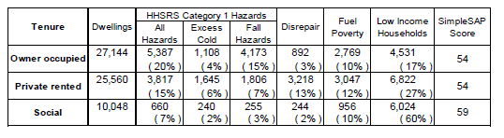

**Current approach**

6.3 Prior to April 2013, the Environmental Health Service only provided a reactive service to deal with service requests regarding disrepair; a property visit would only focus on the issue raised by the tenant. Since then, a more proactive approach has been implemented and a service request now results in a whole house inspection. Rogue landlords and their portfolios are also targeted when they are identified, for example developing illegal subdivisions to avoid HMO licensing. The target increased to proactively inspect and improve 220 properties in 2014/15 to 250 properties in 2015/16.

6.4 The impact of the transformation in approach can be seen in the dramatic change in levels of enforcement action taken by the service of statutory notices:

Table 10 – Summary of enforcement notices for single occupied dwellings

|  |  |  |
| --- | --- | --- |
| Type of service | Year | Number of notices served |
| Reactive | 2011/2012 | 8 |
| Reactive | 2012/2013 | 8 |
| Proactive | 2013/2014 | 94 |
| Proactive/reactive | 2014/2015 | 175 |
| Proactive/reactive | 2015/2016 to date (Nov15) | 219 |

6.5 To date the compliance rate where notices have been served has been one hundred per cent; however as the number of notices served increases, the likelihood for appeals and non-compliance grows. There are grounds therefore for considering the best way of financing the carrying out works in default, (WID), should landlords fail to comply with a statutory notice. The costs of WID is recoverable, although these could amount to thousands of pounds and the recovery may only occur when a property is sold.

**Improving the PRS**

6.6 Despite the increased level of enforcement activity within the sector, there is continued evidence that in the absence of a licensing scheme for properties not let as HMOs, landlords are able to operate within the city on a less controlled basis, and that poor conditions continue to prevail at many properties where there is single family occupation.

6.7 At present there is no barrier to prevent landlords from continuing to operate in the non-HMO sector with the most significant disparity being that landlords of licensed HMOs are subject to the ‘fit a proper’ person test, whereas there is nothing to prevent a landlord who fails this test for HMO licensing, continuing to rent a family dwelling even if they are prosecuted for offences under the Housing Act 2004.

6.8 Selective Licensing would introduce these controls as it would introduce the requirement for every property in the PRS to be licensed and not just HMOs. This would prevent rogue landlords from operating where the scheme applied and require property improvements to be made. The process for introducing a Selective Licensing Scheme is virtually identical to that for introducing Additional Licensing for HMOs. The Council would have to identify the factors affecting the area, consider the best options and be satisfied that the introduction of a Selective Licensing Scheme would provide the best solution. There would also be a minimum of a 10 week period of consultation.

6.9 A selective licensing designation may be made if the area to which it relates satisfies one or more of the following conditions. The area is one experiencing:

* low housing demand (or is likely to become such an area);
* a significant and persistent problem caused by anti-social behaviour;
* poor property conditions;
* high levels of migration;
* high level of deprivation;
* high levels of crime.

6.10 In considering whether to designate an area for selective licensing on the grounds above on property conditions, migration, deprivation and crime a local authority may only make a designation if the area has a high proportion of property in the private rented sector. Nationally the private rented sector currently makes up 19% of the total housing stock in England. The actual number of privately rented properties in a given area may be more or less than this, and if it is more than 19%, the area can be considered as having a high proportion of privately rented properties.

6.11 There are only three wards in the City where the percentage of properties in the PRS is below the national average of 19%. Those three wards contain high percentages of social housing:

Table 11 – Percentage of dwellings in the PRS by ward in Oxford

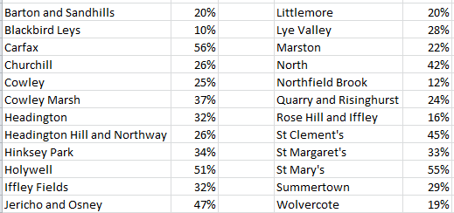

Source: Census 2011

6.12 The data indicates that the wards with the lowest percentage of properties in the PRS still experience as many problems with poor property conditions as other wards:

Figure 15 – Service requests from PRS tenants

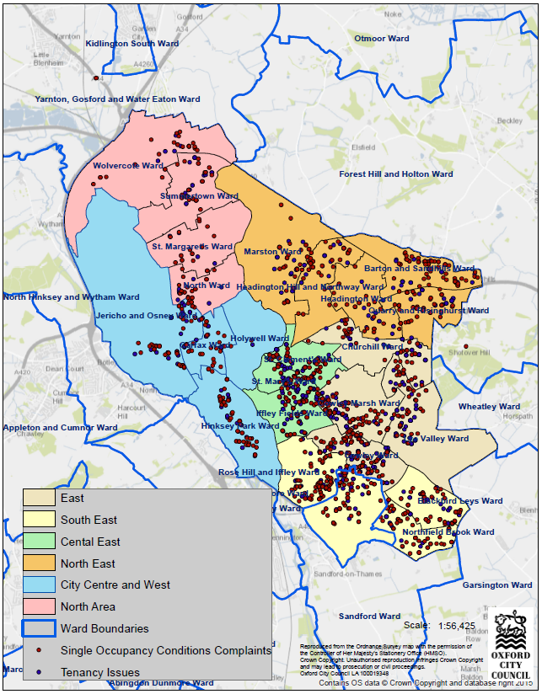

Source: Uniform database

6.13 However, the introduction of a Selective Licensing Scheme is not straightforward and a citywide intervention has been made even more difficult by the changes to the designations contained in the General Consent that came into effect on 1st April 2015. Prior to the change local authorities could designate the whole of their area for Selective Licensing, but now only 20% of the area or the PRS can be licensed without requiring permission from the government.

6.14 If it is not possible to secure approval for a citywide scheme then an option would be to introduce a scheme in the area of the City with the worst housing conditions and highest levels of anti-social behaviour caused by a lack of management.

**Mobile home parks**

6.15 Mobile Home sites are licensable under the Caravan Sites and Control of Development Act 1960. The Mobile Homes Act 2013 amended the Caravan Sites and Control of Development Act 1960 to bring in greater protection to home owners and introduce more effective enforcement options for local authorities.

6.16 There are three mobile home sites in Oxford, two of which are licensable sites under the Act, both of which are exclusively residential sites.

6.17 Section 10A (2) of the Mobile Homes Act 2013 states that a local authority must prepare and publish a fees policy, which is set out below.

6.18 Oxford City Council will charge an application fee for a new licence and will charge for applications to transfer or alter the licence. The Council will also charge a set fee for assessing the park owner’s consultation process, depositing, varying and deleting site rules.

6.19 The Council will charge an annual licence fee based upon the number of homes on the site and a risk rating. The fee will take into account the size of site, the level of compliance on site and the confidence in management. This means that a site which is historically more problematic than another site and therefore requires more officer involvement and more monitoring, would pay a higher licence fee than a well-managed site that requires very little local authority involvement. The banding is as follows:-

* Up to 10 units (Risk Category A-D)
* 11 to 51 units (Risk Category A-D)
* 51 units and over (Risk Category A-D)

6.20 The Risk Category will take the following into account:

* Valid Service Requests received annually from residents and members of the public
* Contraventions of licence conditions and model standards
* Satisfactory certificates for fire safety, gas and electric are available
* Confidence in Management, including concerns raised by other regulators

6.21 The fees shall be set at a level that will recover the full costs of the Council in administering the licence and officer time incurred in carrying out inspections and preparing any subsequent reports or relevant paperwork. Fees will be reviewed annually and will be available on the Council’s website.

6.22 Single owner occupied mobile homes are exempted under the legislation and where a single residential mobile home is occupied under an agreement to which the Mobile Homes Act 1983 applies, no licence fee or annual inspection fee will be charged.

6.23 Any surplus in fees collected will be set against future licence fees and deficits will be recovered in a similar manner.

**Empty properties**

6.24 Empty properties are often the cause of nuisance to neighbouring properties and to the wider community. They are often associated with increased levels of anti-social behaviour, vandalism, squatting, vermin infestations and can often become frequented by drug dealers and be associated with other illegal activities. This can be exacerbated where an empty property has been unoccupied for more than six months. Historically, in conjunction with Empty Property Officer, the Environmental Health Service have been involved with several notable interventions and the long term objective is that this positive joint working initiative will continue.

**Hoarding and dilapidated properties**

6.25 These are properties often occupied by vulnerable persons, sometimes with mental health issues or elderly people struggling to cope. There has been an increased awareness of the issue brought about by publicity and media exposure and a corresponding rise in the number of reports from neighbours and health visitors regarding issues of disrepair, lack of hygiene or accumulations within properties. While these properties are usually owner occupied, the Council has powers under legislation to take action where the situation is likely to cause harm or ill health to the occupier or where there is a wider health issue or where statutory nuisance may exist.

6.26 The cases that come to light are prioritised and referred to other agencies as necessary, particularly when there are safeguarding issues. Known cases are kept under review.

6.27 Enforcement action will be taken when necessary to protect public health, but the Council will primarily seek to provide signposting to assistance and engage with the relevant agencies to help them deal with any underlying issues.

**Health and Housing**

6.28 The link between poor housing and poor health has long been recognised, however it is only recently that it has been made possible to estimate the cost to society of poor housing. In April 2015, the Environmental Health Service subscribed to the Building Research Establishment’s Housing Health Cost Calculator, (HHCC). This was developed to measure the quantitative health impact of work undertaken to reduce or mitigate hazards under the HHSRS and to measure the cost saving to the National Health Service, (NHS) and to society. The Environmental Health Service uses the HHCC to measure the cost saving to the NHS as a result of the work being carried out by the service to reduce or mitigate hazards by landlords of single occupied dwellings in Oxford.

6.29 As the NHS is looking to transform how it delivers services in the future there has been a greater focus on commissioning services that prevent ill health and disease and there is an opportunity that is worth exploring to seek funding for our innovative work in the PRS. The HHCC provides information on the value of the interventions being carried out by the Council in the PRS and allows the savings to the NHS to be authoritatively demonstrated.

**Key Objectives**

6.30 To address the issues highlighted in this chapter, the following key objectives have been identified to help achieve the priority of progressive regulation and improvement of dwellings occupied by families or single occupants.

6.31 There have been some improvements to this sector in Oxford as a result of the rigorous inspection regime and although not a corporate objective, it is a key objective in meeting housing need. Selective Licensing in Oxford however would be a significant undertaking by the Council, and would provide a mechanism to secure the continued improvement of all of the non-HMO stock in the City.

6.32 Proactive inspections of the worst performing properties are to continue to be carried out and whilst the inspection process will incorporate a full ‘whole house’ HHSRS inspection, the main thrust will be to ensure that minimum energy efficiency standards are met throughout the sector by targeting properties with an EPC rating of F or G.

6.33 Renewing the Council’s subscription to the HHCC and to measure cost savings to the NHS and society to enable the Council to seek additional sources of funding.

6.34 Seek additional budget to secure moneys for works carried out at the default of the owner/manager, with recovery of all costs including any technical and administration charges.

6.35 Bringing long-term empty homes back into use is essential, to help meet the high demand for housing and to deal with the impact that they can have on local communities. The service shall continue, where appropriate, to use enforcement action to reduce negative impacts on neighbourhoods and assist with bringing empty properties back into use.

Full details of actions to achieve this priority are contained in Appendix 1.

|  |  |  |
| --- | --- | --- |
| **Objective** | **Action** | **By when** |
| Continue to proactively target rogue landlords operating in the PRS | Remove all category 1 hazards from 250 properties per year | 2016-2019 |
| Improve energy efficiency and reduce carbon emissions in homes in Oxford and address fuel poverty for single household families. | Working with other stake holders, continue the rollout of targeting 100 low EPC scoring properties, (F & G) to improve energy efficiency in the PRS & reduce fuel poverty | October 2016  & continuous through to 2019 |
| Significantly improve management and property conditions and reduce ASB in the PRS | Assess the evidence, identify the best option and subject to legal advice and DCLG approval if necessary, introduce a Selective Licensing Scheme for PRS single occupied dwellings. | January 2017 |
| To ensure non-compliance with improvement notices can be successfully remedied | Seek an approval mechanism for WID | March 2017 |
| Measure cost savings to the NHS and society with the HHCC and seek additional funding from NHS. | Officers to cost each HHSRS completion to calculate costs of improvement work and to determine cost savings | April 2017 |
| Carry out enforcement against private rented properties with no Energy performance Certificate (EPC) | To secure authorisation from the County Council to enforce the provisions of the statutory requirement for landlords to have their properties assessed. | September 2018 |

**Chapter 5**

**7. Priority 3 – Unlawful Dwellings**

*Summary:- This section highlights the impact that unlawful dwellings have on the City. It further details the evidence on the case that continued regulation to secure improvements is required.*

**Context**

7.1 Nationally the phenomenon of ‘beds in sheds’ have been well reported and have regularly featured in media reports, particularly in major conurbations in the south east of England. They are essentially converted garages, or out-buildings, which often lack adequate heating and insulation, sanitation and other necessary facilities, but may be capable of being occupied on a self-contained basis. In some instances they are attached to, or are integral to, the main structure.

7.2 Given the pressures on housing provision and high rental values in Oxford, it is no surprise that instances of such developments have been reported in the city.

7.3 The Council financed an Unlawful Development project from April 2013 to March 2015 with a budget of £150k and successfully bid for match funding from the governments Rogue Landlord Programme, giving a total of £300k and the additional funding became available in January 2014 and also ran until March 2015. The purpose of the project was to:

* provide some certainty on the scale of the problem in Oxford
* take enforcement action to act as a deterrent to unscrupulous developers and
* demonstrate to residents that the Council will take action against unlawful developments to prevent the proliferation of poor quality properties in Oxford

7.4 The project was highly innovative and involved flying a plane across the city and providing thermal images to identify suspected unlawful developments.

7.5 Action to Date:

* Total number of properties identified with a heat profile and

of a size to have potential for residential use 2761

* Number investigated and identified using desk top data 2117
* Total number requiring on-site investigation 1625
* Total number of premises visited 934
* Number where access gained 646
* Total number of cases where statutory action taken 128
* Number HMO’s where variations issued to the license 42

7.6 Enforcement action was therefore taken at 14% of the premises visited by officers and it is estimated that there are approximately 300 “beds and sheds” in Oxford.

7.7 Following the end of the project the Council provided additional funding of £60k for the scheme to continue operating at a reduced level until the end of 2015/16. The challenge for the Council is to continue to deal with existing unlawful developments whilst providing an effective deterrent to developers, landlords and individuals who are prepared to create more such developments.

Figure 16 – Numbers of unlawful developments in Oxford

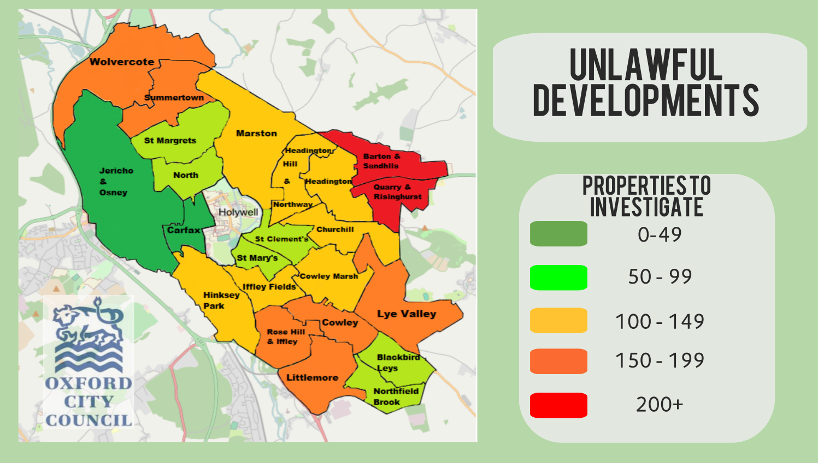

Source: Oxford City Council Thermal imaging data

**Key Objectives**

7.8 To address the issues highlighted in this chapter, the following key objectives have been identified to help achieve the priority of regulating unlawful dwellings.

7.9 The joint initiative with Planning Enforcement and other stakeholders to regulate and take appropriate action on unauthorised structures will continue, however the function will be absorbed into and led by teams in the Environmental Health Service. Despite the reduction in resources an active approach to enforcement action will continue to be taken to act as a deterrent which is reflected in the proposed target.

Full details of actions to achieve this priority are contained in Appendix 1.

|  |  |  |
| --- | --- | --- |
| **Objective** | **Action** | **By when** |
| Ensure unlawful structures are dealt with using planning/building control and housing legislation. | Following due process serve 10 notices under the Town & Country Planning Act  Following due process serve 10 Prohibition Orders under the Housing Act 2004  Ensure successful enforcement action is publicised | March 2017 |
| Continue working with external agencies HMRC and UK Border Agency when required | Carrying out joint visits and sharing information. | September 2017 |

**Chapter 6**

**8. Priority 4 – Housing Assistance**

*Summary:- This section highlights the work to improve vulnerable householders within the City. It further details the actions that will help deliver a robust scheme to ensure that it continues to secure improvements in this sector.*

**Context**

8.1 Whilst Oxford has the youngest median age - 29.9 years - of any place in England and Wales, Oxford has less elderly residents than the English average.

Figure 17 – Oxford and UK population by gender and age, 2011 Census

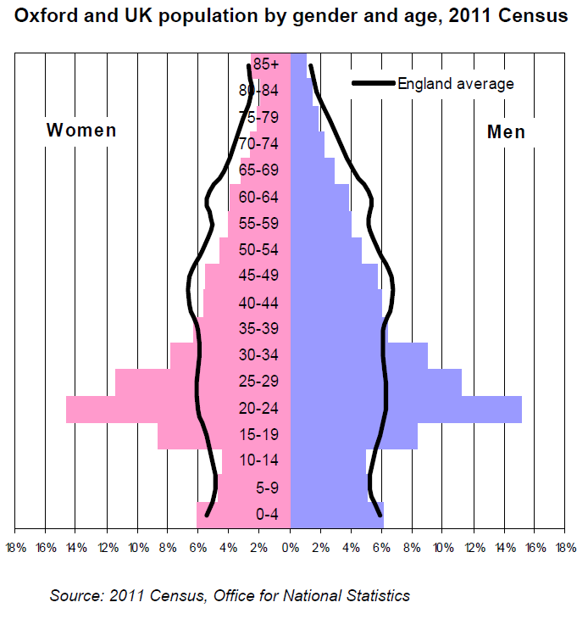

8.2 However, across Oxfordshire it is anticipated that the elderly population will increase significantly and therefore the demand for assistance and social care will also rise:

Table 12 – Growth in elderly population in Oxfordshire

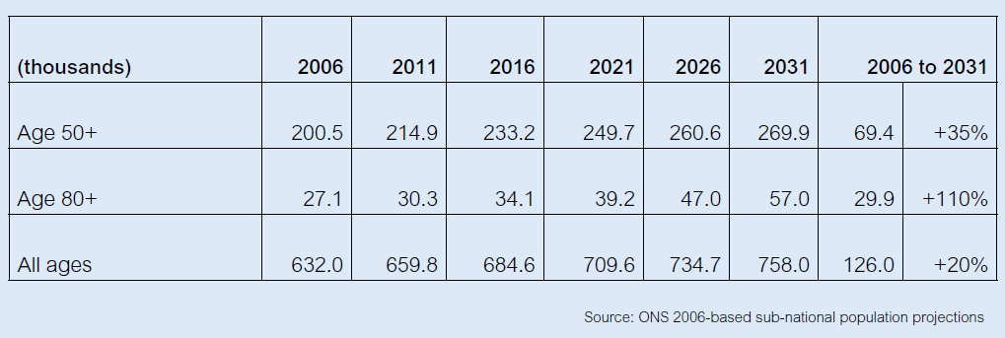

8.3 According to the Office for National Statistics the number of people living in Oxford aged over 80 increased by 24% from 4,500 to 5.600 between 1988 and 2008 and this is forecast to rise to 6,600 by 2028.

8.4 This increase in an elderly population will inevitably mean a rise in demand in the social care and assistance needed to enable people to remain in their homes and maintain their health and wellbeing.

**The Home Improvement Agency**

8.5 The Oxford Home Improvement Agency, (HIA) is a service which offers invaluable support to the most vulnerable residents within Oxford. The HIA receives funding from Oxfordshire County Council as it delivers services that are fundamentally linked to the County Council’s Social and Adult Care responsibilities.

8.6 The purpose is to help occupiers remain safe, secure, independent and warm in their own homes. The agency service is available to people aged 60 and over, or persons on a low income, suffering from a long term health condition or a disability and who are vulnerable and need help repairing, maintaining or adapting their home. It is not always easy for older and disabled people to repair or adapt their home. This can be for many reasons including cost, the stress involved in organising work and the fear of unsatisfactory builders.

**Disabled Facilities Grants, (DFG)**

8.7 The Council is under a legal duty to provide DFGs. Disabled children are not means tested, but all eligible adults are means tested; with the current maximum grant for all DFGs being £30,000. A DFG provides essential adaptations to the property that are reasonable and practicable to help eligible disabled people live in their home. Where adaptations are necessary, a DFG offers help with the cost of providing these to the home, making it easier for the disabled person to continue living there. A DFG covers adaptations such as stair lifts, ramped access, level/low access shower or the installation of a ground floor bathroom. The HIA works closely with the County Council’s Occupational Therapists to provide the best solutions for all the cases that are referred to the Council.

**Relocation Grants**

8.8 This is a grant to enable disabled residents to alternative accommodation when it is not reasonable or practicable to adapt their existing home. The maximum grant available is £15,000, to assist with costs such as removal expenses, solicitor’s fees, estate agents fees and stamp duty. The grant is payable on completion of the move.

**Small Repairs Service**

8.9 The City Council undertake a small repairs service available to owner/occupiers and tenants who are aged 60 and over, suffering from a long term health condition and who are disabled. This service covers small plumbing, electrical and basic house hold repairs. The labour charge is currently £19 inclusive of VAT plus the cost of any materials used. As well as helping people to live independently, the repairs service can also play an important role in enabling patients to be discharged more speedily from hospital.

**Flexible Home Improvement Loans**

8.10 This is a Government supported loan run by a Company formed by a consortium of 16 local authorities, including the Council. The aim is to assist clients in releasing some of the equity in their property to enable home improvements to be carried out. The loan scheme is for owner/occupiers aged 60 and over and designed to help with work to improve the comfort, safety, security and repairs to their home.

8.11 The funding levels for Flexible Home Improvement Loans are released quarterly by the Loan Company and to date the Council has been able to successfully spend all its allocation.

**Essential Repair Grants (ERG)**

8.12 The Council has a discretionary capital budget of £50,000 for home improvement grants. The ERG is a means tested grant, to help owner occupiers on low incomes carry out essential repairs to their homes to the maximum value of £5,000. This is to ensure that minimum health & safety standards are met and that fuel poverty, health, and environmental issues are properly addressed. Where repair work is necessary, an ERG can help with the costs of providing these repairs, to making it easier for the owner-occupier to continue living in their own homes. If the home owner sells their home within 10 years of receiving the ERG the whole of the grant is repaid.

Figure 18 – Yearly referrals for Disabled Facilities Grants & Small Repairs (15/16 at Q3)

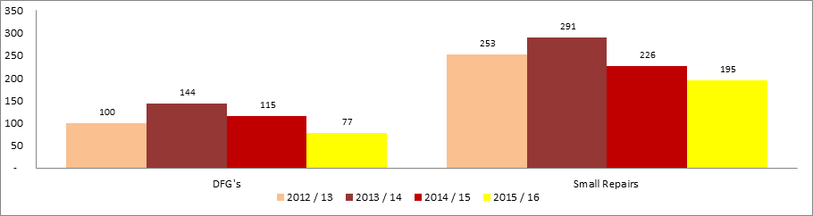

Figure 19 – Yearly referrals for Essential Repair Grants & Flexible Home Improvement Loans (15/16 at Q3)

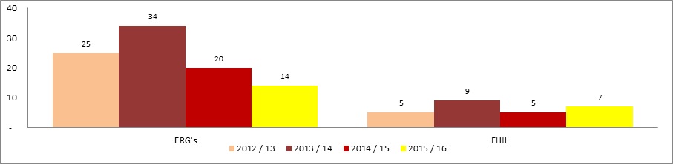

**Winter Warmth Grants**

8.13 In previous years, the Council has brought in additional funding for key energy efficiency works such as new gas condensing boilers and insulation for vulnerable private sector tenants. This has been led by the Environmental Sustainability Service which has been extremely successful in bidding for funding and attracting investment.

8.14 The HIA acts as a delivery mechanism for the funding as it is already set up to administer grants and members of the public and businesses can be assured of an efficient, effective and accountable service.

8.15 So far, for 2015/16, £20,000 has been invested by the City Council which at December 2015 had brought in an additional funding of £6,000. These grants are administered by the HIA. As a key way of meeting fuel needs of vulnerable tenants, it is our intention to continue this work whenever funding permits.

**Key Objectives**

8.16 To address the issues highlighted in this chapter, the following key objectives have been identified to help achieve the priority of providing housing assistance.

8.17 There continues to be a high volume of referrals for DFG’s so it is vital that there is continued assistance for people with disabilities or older people who are deemed vulnerable to adapt or repair their homes. Ensuring 100% of the budget is spent and that it offers value for money is key to achieving this objective.

8.18 Delivering the Flexible Home Improvement Loans, allocating all our budget and using other Council’s unspent allocations where possible.

8.19 Seeking funding opportunities to help reduce fuel poverty and working with the Environmental Sustainability Service to deliver assistance.

Full details of actions to achieve this priority are contained in Appendix 1.

|  |  |  |
| --- | --- | --- |
| **Objective** | **Action** | **By when** |
| * Ensure 100% of the DFG budget is spent | Continued promotion of Home Improvement Agency services to reach vulnerable groups. | 2016 - 2019 |
| Provide an excellent HIA Service | Ensure 70 people are helped by the Home from Hospital scheme.  Complete 80 Repairs & Improvements and Major Adaptations jobs  Process 100 new referrals for Repairs & Improvements and Major Adaptations  Complete 350 Minor Adaptations and Handyperson & Maintenance Services jobs  Achieve overall customer satisfaction of HIA services of 95% | 2016-2019 |
| Reduce fuel poverty for vulnerable residents. Secure funding for fuel poverty works | Work with internal and external partners to relieve fuel poverty by addressing the energy efficiency of buildings and targeting vulnerable residents with related health issues | 2016-2019 |
| Promote the Flexible Home Improvement Loans scheme and spend/commit £160,000 | Meet with community groups, produce promotional literature. | 2016-2019 |
| Achieve the Foundations Standard and attain membership thereby extending our services to the wider community.  (Foundations is the National Body for Home Improvement Agency and Handy person Services) | To ensure that the HIA remains fit for purpose in this area we shall attend relevant training and review the skills areas in which we operate to meet the needs of the HIA Sector. | March 2018 |

Chapter 7

9. Private Rented Sector Enforcement

*Summary:- This section sets out the Council’s approach to enforcement to secure improvements in this sector.*

Context

9.1 Oxford City Council has a strong reputation as a regulator and believes that firm but fair enforcement plays a significant role in ensuring that minimum statutory standards are met in the private rented sector.

Guidance

9.2 Oxford City Council uses compliance advice, guidance and support as a first response in the case of many breaches of legislation that are identified. Advice is provided, sometimes in the form of a warning letter, to assist individuals and businesses in rectifying breaches as quickly and efficiently as possible, avoiding the need for further enforcement action. A warning letter (sometimes called an ‘informal caution’) will set out what should be done to rectify the breach and to prevent re-occurrence. If a similar breach is identified in the future, this letter will be persuasive in considering the most appropriate enforcement action to take on that occasion. Such a letter cannot be cited in court as a previous conviction but it may be presented in evidence.

**Statutory (Legal) Notices**

9.3 In respect of many breaches Oxford City Council has powers to issue statutory notices. Such notices are legally binding. Failure to comply with a statutory notice can be a criminal offence and may lead to prosecution and/ or, where appropriate, the carrying out of work in default. As the Council relies heavily upon statutory notices to ensure compliance, it will view a breach of a notice as a serious matter.

9.4 The Council will normally charge where legislation permits the recovery of costs for serving statutory notices and the charges will be available on the Council’s website.

**Financial penalties**

9.5 Oxford City Council has powers to issue fixed penalty notices in respect of some breaches. If a fixed penalty is paid in respect of a breach Oxford City Council will not take any further enforcement action in respect of that breach. If a fixed penalty is not paid, Oxford City Council may commence criminal proceedings or take other enforcement action in respect of the breach.

9.6 Where there is a legislative option for the Council to choose the amount payable for a financial penalty, the Council’s policy will be to charge the maximum permitted level. The charges will be available on the Council’s website.

9.7 Where appropriate the Council will apply for Rent Repayment Orders and support tenants who wish to apply for a Rent Repayment Order.

**Simple Caution**

9.8 Oxford City Council has the power to issue simple cautions (previously known as ‘formal cautions’) as an alternative to prosecution for some less serious offences, where a person admits an offence and consents to the simple caution. Where a simple caution is offered and declined, Oxford City Council is likely to consider prosecution.

9.9 A simple caution will influence how Oxford City Council and others deal with any similar breaches in the future, and may be cited in court if the offender is subsequently prosecuted for a similar offence.

9.10 Simple cautions will be used in accordance with Ministry of Justice Guidance and any other relevant guidance.

**Prosecution**

9.11 When deciding whether to prosecute Oxford City Council has regard to the provisions of [The Code for Crown Prosecutors](http://www.cps.gov.uk/publications/code_for_crown_prosecutors) as issued by the Director of Public Prosecutions and whether the case is in the public interest.

9.12 Prosecution will only be considered where Oxford City Council is satisfied that it has sufficient evidence to provide a realistic prospect of conviction against the defendant(s).

9.13 Before deciding that prosecution is appropriate, Oxford City Council will have particular regard to the following public interest criteria:

* How serious is the offence committed?
* What is the level of culpability of the suspect?
* What are the circumstances of and the harm caused to the victim?
* Was the suspect under the age of 18 at the time of the offence?
* What is the impact on the community?
* Is prosecution a proportionate response?
* Do sources of information require protecting?

9.14 The Council expects that, in the public interest, enforcing authorities should normally prosecute, or recommend prosecution, where, following an investigation or other regulatory contact, one or more of the following circumstances apply. Where:

* a breach of the legislation resulted in a death
* the gravity of an alleged offence, taken together with the seriousness of any actual or potential harm, or the general record and approach of the offender warrants it;
* there has been reckless disregard of legislative requirements;
* there have been repeated breaches which give rise to significant risk, or persistent and significant poor compliance;
* the breach has been carried out without or in serious non-compliance with an appropriate licence or permission;
* a dutyholder’s standard of compliance is found to be far below what is required by law and to be giving rise to significant risk;
* there has been a failure to comply with a statutory notice; or there has been a repetition of a breach that was subject to a simple caution;
* false information has been supplied wilfully, or there has been an intent to deceive, in relation to a matter which gives rise to significant risk;
* officers have been intentionally obstructed in the lawful course of their duties.

9.15 In deciding on the public interest the Council will make an overall assessment based on the circumstances of each case and will consider all relevant circumstances carefully, including local and corporate priorities.

**Proceeds of Crime**

9.16 Where appropriate the Council will consider the use of the Proceeds of Crime Act 2002. The Proceeds of Crime Act allows Local Authorities to recover assets that have been accrued through criminal activity.

Appendix 1 - Private Sector Housing Policy Action Plan

**Private Sector Housing Policy Priority 1 – Additional Licencing**

|  |  |  |
| --- | --- | --- |
| **Objective** | **Action** | **By when** |
| Prevent homelessness/illegal eviction/harassment of tenants across all tenures of the PRS | Partnership/interagency working with Shelter, Citizens Advice Bureau, (CAB), Home choice, Housing Options. Provide advice & education to landlords & tenants. Carry out a consultation exercise to establish the best methods of providing information and advice to tenants and implement the resulting Action Plan. | May 2016 |
| Review of the Oxford City Landlords Accreditation Scheme, (OCLAS) and 150 landlords/agents accredited | A more robust accreditation scheme to provide training/CPD to agents/landlords to drive up standards in a non-enforcement capacity  Explore options with landlords and if appropriate establish further landlord incentives  Roll out training courses for non- accredited landlords/non-fit & proper landlords etc to promote positive engagement. | October 2016  March 2017  March 2017 |
| Gain a better understanding of the true extent of the numbers of HMO’s that exist within the city to allow for more focused targeting for licensing purposes. | Use existing databases more effectively and identify additional sources of information that can be used to indicate suspected unlicensed HMOs | October 2016 |
| Improve energy efficiency and reduce carbon emissions in HMO’s in Oxford and address fuel poverty.  Carry out enforcement against private rented properties with no Energy performance Certificate (EPC) | To secure authorisation from the County Council to enforce the provisions of the statutory requirement for landlords to have their properties assessed. | September 2018 |
| Achieve corporate target for percentage of HMOs licensed | Continue to licence HMOs and ensure focus is on identifying unlicensed HMOs | March 2019 |

**Private Sector Housing Policy Priority 2 – Regulation of single occupied/family dwellings**

|  |  |  |
| --- | --- | --- |
| **Objective** | **Action** | **By when** |
| Continue to proactively target rogue landlords operating in the PRS | Remove all category 1 hazards from 250 properties per year | 2016-2019 |
| Improve energy efficiency and reduce carbon emissions in homes in Oxford and address fuel poverty for single household families. | Working with other stake holders, continue the rollout of targeting 100 low EPC scoring properties, (F & G) to improve energy efficiency in the PRS & reduce fuel poverty | October 2016  & continuous through to 2019 |
| Reduce the number of empty properties in Oxford | Working with the Empty Property Officer, assist with bringing back into use long term empty properties to reduce the burden on housing shortage and prevent anti-social behaviour | 2016-2019 |
| Significantly improve management and property conditions and reduce ASB in the PRS | Assess the evidence, identify the best option and subject to legal advice and DCLG approval if necessary introduce a Selective Licensing Scheme for PRS single occupied dwellings. | January 2017 |
| To ensure non-compliance with improvement notices can be successfully remedied | Seek approval mechanism for WID spend | March 2017 |
| Measure cost savings to the NHS and society with the HHCC and seek additional funding from NHS. | Officers to cost each HHSRS completion to calculate costs of improvement work and to determine cost savings | April 2017 |

**Private Sector Housing Policy Priority 3 – Unlawful Dwellings**

|  |  |  |
| --- | --- | --- |
| **Objective** | **Action** | **By when** |
| Ensure unlawful structures are dealt with using planning/building control and housing legislation. | Following due process serve 10 notices under the Town & Country Planning Act  Following due process serve 10 Prohibition Orders under the Housing Act 2004  Ensure successful enforcement action is publicised | March 2017 |
| Continue working with external agencies HMRC and UK Border Agency when required | Carrying out joint visits and sharing information. | September 2017 |

**Private Sector Housing Policy Priority 4 – Housing Assistance**

|  |  |  |
| --- | --- | --- |
| **Objective** | **Action** | **By when** |
| * Ensure 100% of the DFG budget is spent | Continued promotion of Home Improvement Agency services to reach vulnerable groups. | 2016 - 2019 |
| Provide an excellent HIA Service | Ensure 70 people are helped by the Home from Hospital scheme.  Complete 80 Repairs & Improvements and Major Adaptations jobs  Process 100 new referrals for Repairs & Improvements and Major Adaptations  Complete 350 Minor Adaptations and Handyperson & Maintenance Services jobs  Achieve overall customer satisfaction of HIA services of 95% | 2016-2019 |
| Reduce fuel poverty for vulnerable residents. Secure funding for fuel poverty works | Work with internal and external partners to relieve fuel poverty by addressing the energy efficiency of buildings and targeting vulnerable residents with related health issues | 2016-2019 |
| Promote the Flexible Home Improvement Loans scheme and spend/commit £160,000 | Meet with community groups, produce promotional literature. | 2016-2019 |
| Achieve the Foundations Standard and attain membership thereby extending our services to the wider community.  (Foundations is the National Body for Home Improvement Agency and Handy person Services) | To ensure that the HIA remains fit for purpose in this area we shall attend relevant training and review the skills areas in which we operate to meet the needs of the HIA Sector. | March 2018 |

**Appendix 2**

**Glossary of Abbreviations**

|  |  |  |  |
| --- | --- | --- | --- |
| OCLAS  CAB | Oxford City Landlord Accreditation Scheme  Citizens Advice Bureau |  | SHMA Strategic Housing Market Assessment |
| CLG | Communities and Local Government |  | BRE Building Research Establishment |
| CPO | Compulsory Purchase Order |  | ONS Office of National Statistics |
| ERG  DFG | Essential Repair Grant  Disabled Facilities Grant |  | EHS English Housing Survey  LGA Local Government Association |
| EDMO | Empty Dwelling Management Order |  |  |
| HHSRS  HHCC | Housing Health and Safety Rating System  Housing Health Cost Calculator |  |  |
| HIA | Home Improvement Agency |  |  |
| HMO | House in Multiple Occupation |  |  |
| HMR | Housing Market Renewal |  |  |
| IMO  LHA | Interim Management Order  Local Housing Authority |  |  |
| PRS | Private rented sector |  |  |
|  |  |  |  |
| PSH | Private sector housing |  |  |
|  |  |  |  |